


ALL SAINTS SUNDAY
NOVEMBER 2, 2025

OUR REDEEMER LUTHERAN CHURCH

18444 Old Glenn High way – P.O. Box 670150 -- Chugiak, Alaska 99567

907-688-2157 | www.orlc-ak.org

Vacancy Pastor Jonathan Rockey (907-841-4066) jonrock53@mtaonline.net

Lauren Johnston – Children & Youth Director: lauren@orlc-ak.org

Sally Coburn (Parish Nurse): parishnurse@orlc-ak.org

Servants and Missionaries: ORLC Members

Our Mission:

True to God’s Word, We Walk with Christ:
Welcoming, Loving, Serving, Sharing.

Good Morning and Welcome! What a great joy to have you here with us today praising God and receiving His gifts. If you are a guest or visiting with us, toss one of those Welcome cards in your pew into the offering basket--we’d love to connect! Should you need it, there is a “cry room” next to the church office on the main level. Feel free to ask an usher if you need assistance. Welcome!

A Word about Holy Communion
We celebrate the Lord’s Supper every Sunday at ORLC. In this meal, instituted by the Lord Himself, we receive the True Body and True Blood of our Lord Jesus Christ under the bread and wine for the forgiveness of our sins and the strengthening of our faith. We believe that the Lord is truly present during this Holy Meal, and we approach the altar in humility and gratitude. Baptized believers in Christ who also share our confession at this altar are welcome to commune.

COMMUNION CUPS The center, gold-colored cups are alcohol-free.
GLUTEN FREE WAFERS Available upon request; simply ask the pastor or an elder.
ORDER OF WORSHIP
Divine Service, Setting 1 – page 151
Welcome

Sharing of Peace

Hymn of Invocation
For All The Saints LSB 677, vv. 1-4

P: In the name of the Father and of the Son and of the Holy Spirit.
C: Amen.


Confession and Forgiveness
P: If we say we have no sin, we deceive ourselves, and the truth is not in us.
C: But if we confess our sins, God, who is faithful and just, will forgive our sins
and cleanse us from all unrighteousness. 1 John 1:8-9

(We silently reflect on the fact that though our sin is great, God’s mercy is greater.)

P: Let us then confess our sins to God our Father.
C: Most merciful God, we confess that we are by nature sinful and unclean. We have sinned against You in thought, word, and deed, by what we have done and by what we have left undone. We have not loved You with our whole heart; we have not loved our neighbors as ourselves. We justly deserve Your present and eternal punishment. For the sake of Your Son, Jesus Christ, have mercy on us. Forgive us, renew us, and lead us, so that we may delight in Your will and walk in Your ways to the glory of Your holy name. Amen.
P: Almighty God in His mercy has given His Son to die for you and for His sake forgives you all your sins. As a called and ordained servant of Christ, and by His authority, I therefore forgive you all your sins in the name of the Father and of the Son and of the Holy Spirit. John 20:19-23
C: Amen.

Introit ~ Psalm 31:1, 3, 5; antiphon: Revelation 7:14b
These are the ones coming out of the great tribulation.
They have washed their robes and made them white in the blood of the Lamb.
In you, O Lord, do I take refuge; let me never be put to shame;
in your righteousness deliver me.
For you are my rock and my fortress;
and for your name’s sake you lead me and guide me.
Into your hand I commit my spirit;
you have redeemed me, O Lord, faithful God.
Glory be to the Father and to the Son
and to the Holy Spirit;
as it was in the beginning,
is now, and will be forever. Amen.
These are the ones coming out of the great tribulation.
They have washed their robes and made them white in the blood of the Lamb.

Kyrie ~ Lord, Have Mercy

P: In peace, let us pray to the Lord.

C:
P: For the peace from above, and for our salvation, let us pray to the Lord.

C:


P: For the peace of the whole world, for the well-being of the Church of God, and for the unity of all, let us pray to the Lord.

C:

P: For this holy house, and for all who offer here their worship and praise, let us pray to the Lord.

C:

P: Help, save, comfort, and defend us, gracious Lord.

C:

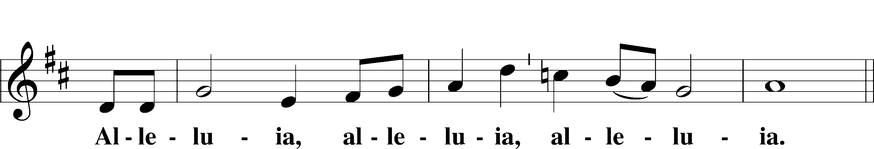
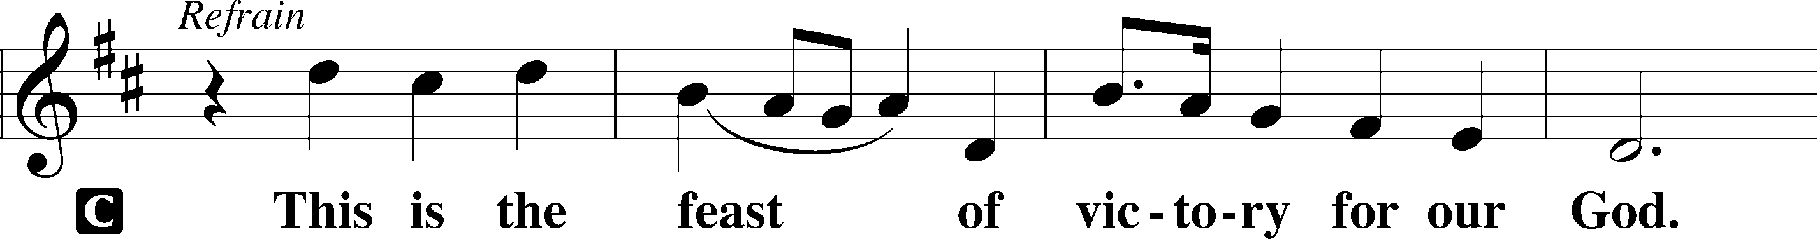
Hymn of Praise ~ This Is the Feast

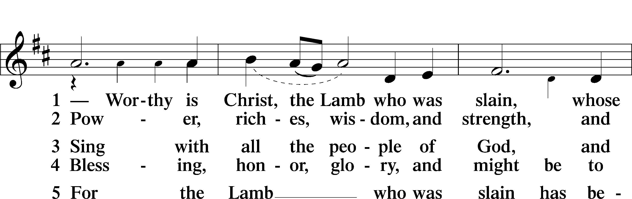

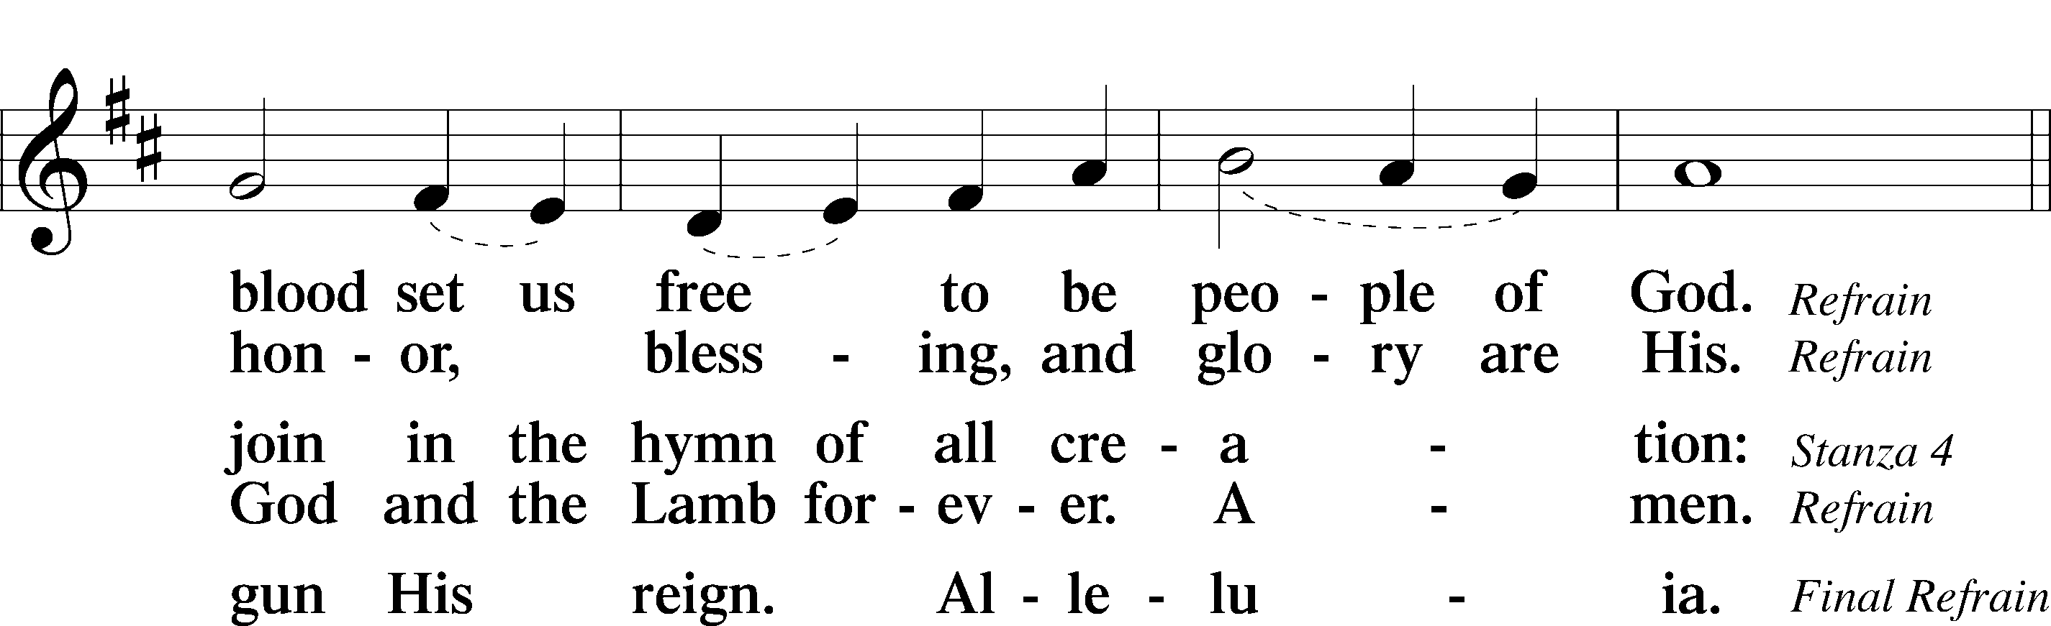

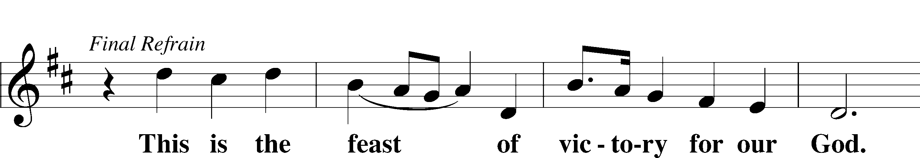

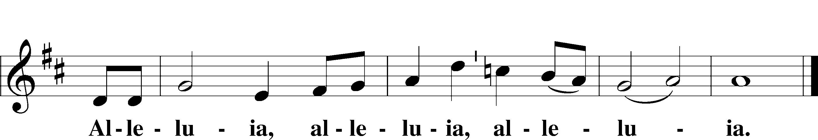

Prayer of the Day

P: The Lord be with you.
C: And also with you.
P: Let us pray
C: Almighty and everlasting God, You knit together Your faithful people of all times and places into one holy communion, the mystical body of Your Son, Jesus Christ. Grant us so to follow Your blessed saints in all virtuous and godly living that, together with them, we may come to the unspeakable joys You have prepared for those who love You; through Jesus Christ, our Lord, who lives and reigns with You and the Holy Spirit, one God, now and forever. Amen.

First Lesson…………………….…….…................................... Revelation 7:9–17
⁹After this I looked, and behold, a great multitude that no one could number, from every nation, from all tribes and peoples and languages, standing before the throne and before the Lamb, clothed in white robes, with palm branches in their hands, ¹⁰and crying out with a loud voice, “Salvation belongs to our God who sits on the throne, and to the Lamb!” ¹¹And all the angels were standing around the throne and around the elders and the four living creatures, and they fell on their faces before the throne and worshiped God, ¹²saying, “Amen! Blessing and glory and wisdom and thanksgiving and honor and power and might be to our God forever and ever! Amen.”

¹³Then one of the elders addressed me, saying, “Who are these, clothed in white robes, and from where have they come?” ¹⁴I said to him, “Sir, you know.” And he said to me, “These are the ones coming out of the great tribulation. They have washed their robes and made them white in the blood of the Lamb.
¹⁵“Therefore they are before the throne of God,
and serve him day and night in his temple;
and he who sits on the throne will shelter them with his presence.
¹⁶They shall hunger no more, neither thirst anymore;
the sun shall not strike them,
nor any scorching heat.
¹⁷For the Lamb in the midst of the throne will be their shepherd,
and he will guide them to springs of living water,
and God will wipe away every tear from their eyes.”

Lector: This is the Word of the Lord.
People: Thanks be to God.

Epistle Reading……………………..…..………………….… 1 John 3:1–3
¹See what kind of love the Father has given to us, that we should be called children of God; and so we are. The reason why the world does not know us is that it did not know him. ²Beloved, we are God’s children now, and what we will be has not yet appeared; but we know that when he appears we shall be like him, because we shall see him as he is. ³And everyone who thus hopes in him purifies himself as he is pure.

Lector: This is the Word of the Lord.
People: Thanks be to God.

Alleluia

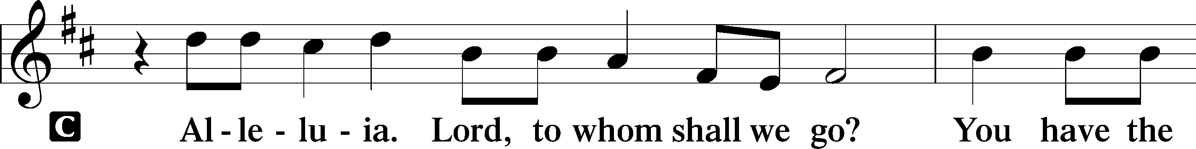

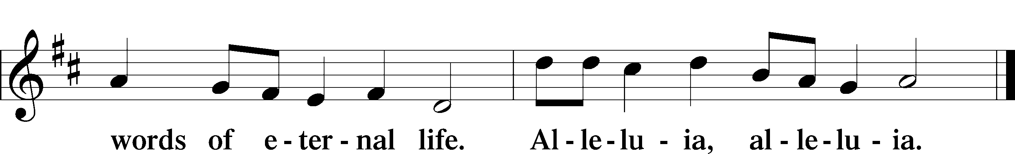

P: The Holy Gospel according to St. Matthew, the Fifth chapter.

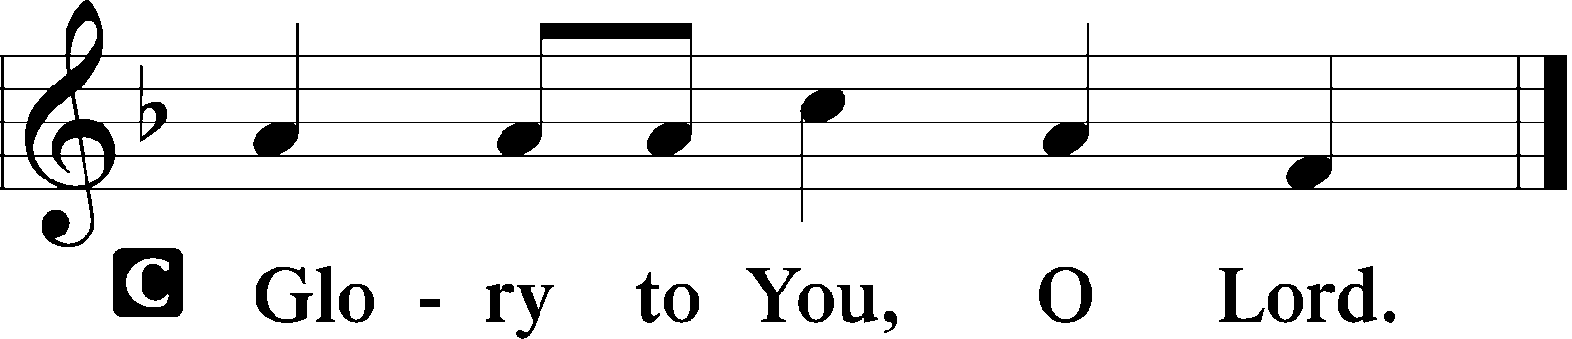

C:

The Gospel Reading…………………………………….…………………. Matthew 5:1–12
¹Seeing the crowds, [Jesus] went up on the mountain, and when he sat down, his disciples came to him.
²And he opened his mouth and taught them, saying:
³“Blessed are the poor in spirit, for theirs is the kingdom of heaven.
⁴“Blessed are those who mourn, for they shall be comforted.
⁵“Blessed are the meek, for they shall inherit the earth.
⁶“Blessed are those who hunger and thirst for righteousness, for they shall be
satisfied.
⁷“Blessed are the merciful, for they shall receive mercy.
⁸“Blessed are the pure in heart, for they shall see God.
⁹“Blessed are the peacemakers, for they shall be called sons of God.
¹⁰“Blessed are those who are persecuted for righteousness’ sake, for theirs is the kingdom of heaven.
¹¹“Blessed are you when others revile you and persecute you and utter all kinds of evil against you falsely on my account. ¹²Rejoice and be glad, for your reward is great in heaven, for so they persecuted the prophets who were before you.”

P: This is the Gospel of the Lord.
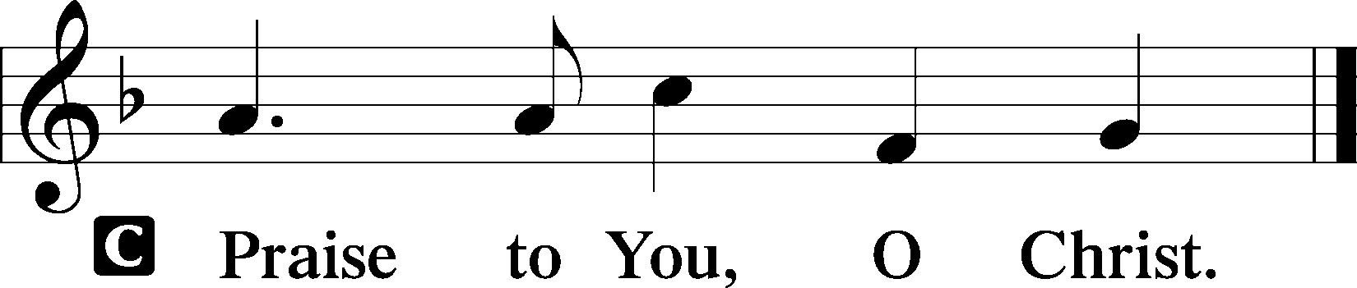
C:

Children’s Message

Hymn of the Day
For All Your Saints in Warfare LSB 517, vv. 1, 4, 3

Sermon – “Assurance of the Lamb for our Tribulation in This World – Revelation 7

Nicene Creed
I believe in one God, the Father Almighty,
maker of heaven and earth and of all things visible and invisible.

And in one Lord Jesus Christ,
the only-begotten Son of God, begotten of His Father before all worlds,
God of God, Light of Light, very God of very God,
begotten, not made, being of one substance with the Father,
by whom all things were made;
who for us men and for our salvation came down from heaven
and was incarnate by the Holy Spirit of the virgin Mary and was made man;
and was crucified also for us under Pontius Pilate.
He suffered and was buried.
And the third day He rose again according to the Scriptures
and ascended into heaven and sits at the right hand of the Father.
And He will come again with glory to judge both the living and the dead,
whose kingdom will have no end.

And I believe in the Holy Spirit, the Lord and giver of life,
who proceeds from the Father and the Son,
who with the Father and the Son together is worshiped and glorified,
who spoke by the prophets.
And I believe in one holy Christian and apostolic Church,
I acknowledge one Baptism for the remission of sins,
and I look for the resurrection of the dead and the life of the world to come.
Amen.
Offerings

Prayers of the Church

Preface


P: The Lord be with you.

C:


P: Lift up your hearts.

C:

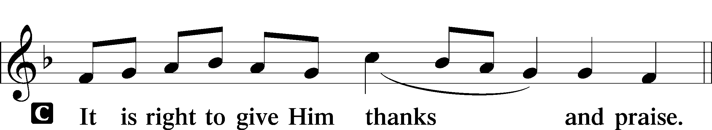
P: Let us give thanks to the Lord our God.

C:

P: It is truly good, right, and salutary that we should at all times and in all places give thanks to You, holy Lord, almighty Father, everlasting God, through Jesus Christ, our Lord, who on this day overcame death and the grave and by His glorious resurrection opened to us the way of everlasting life. Therefore with angels and archangels and with all the company of heaven we laud and magnify Your glorious name, evermore praising You and saying:

Sanctus
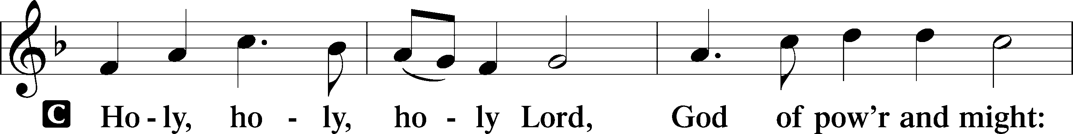
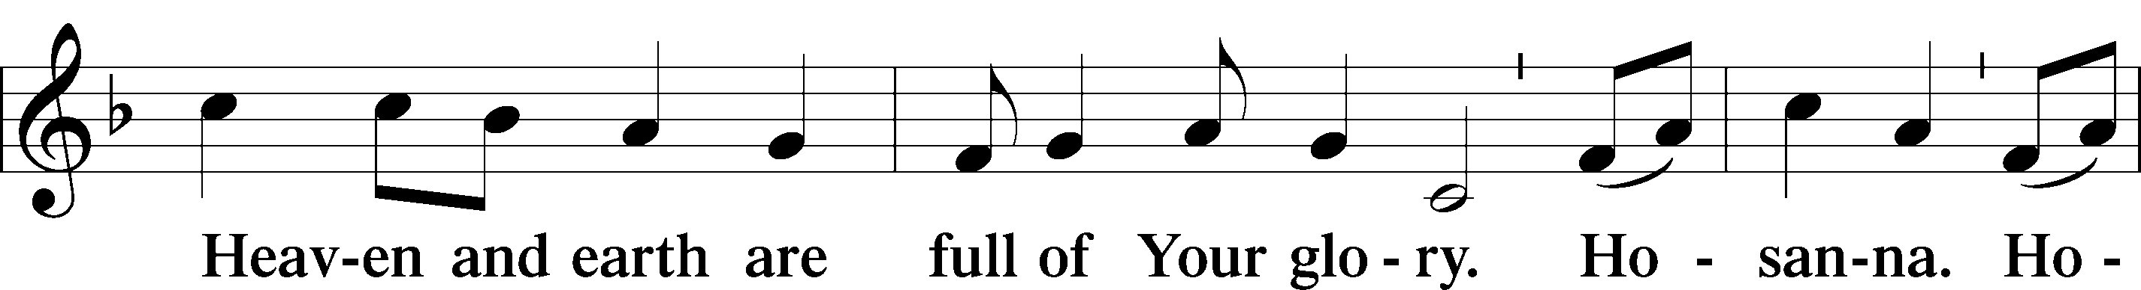
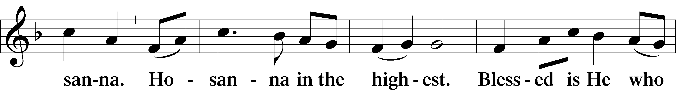
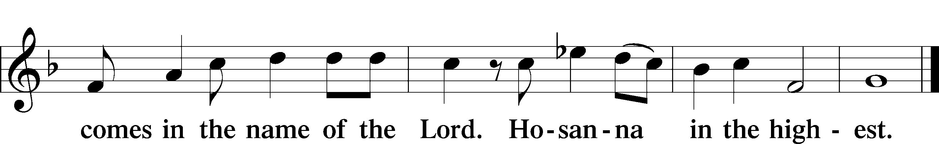

Prayer of Thanksgiving

P: Blessed are You, Lord of heaven and earth, for You have had mercy on those
whom You created and sent Your only-begotten Son into our flesh to bear our sin and be our Savior. With repentant joy we receive the salvation accomplished for us by the all-availing sacrifice of His body and His blood on the cross.

Gathered in the name and the remembrance of Jesus, we beg You, O Lord, to forgive, renew, and strengthen us with Your Word and Spirit. Grant us faithfully to eat His body and drink His blood as He bids us do in His own testament.
Gather us together, we pray, from the ends of the earth to celebrate with all the faithful the marriage feast of the Lamb in His kingdom, which has no end. Graciously receive our prayers; deliver and preserve us. To You alone, O Father, be all glory, honor, and worship, with the Son and the Holy Spirit, one God, now and forever.
C: Amen.

Lord’s Prayer

P: Lord, remember us in Your kingdom and teach us to pray:
C: Our Father who art in heaven,
hallowed be Thy name,
Thy kingdom come,
Thy will be done on earth as it is in heaven;
give us this day our daily bread;
and forgive us our trespasses as we forgive those who trespass against us;
and lead us not into temptation, but deliver us from evil.
For Thine is the kingdom and the power and the glory forever and ever. Amen.

The Words of our Lord 1 Corinthians 11:23-25

Pax Domini - The Peace of the Lord

P: The peace of the Lord be with you always.

C:

Agnus Dei ~ Lamb of God

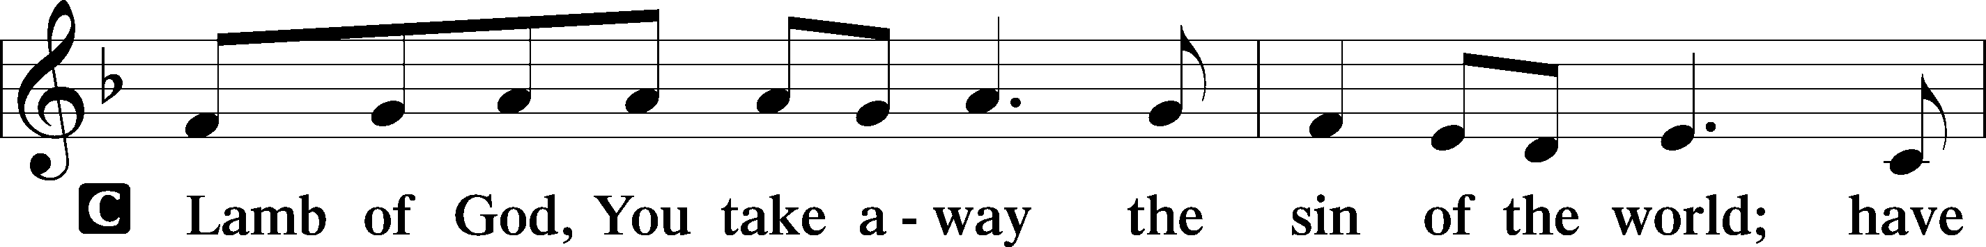
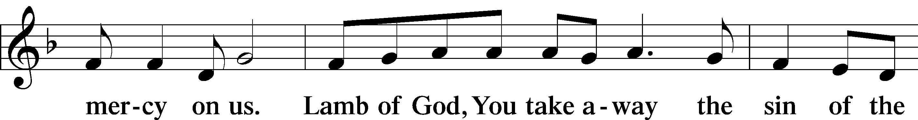
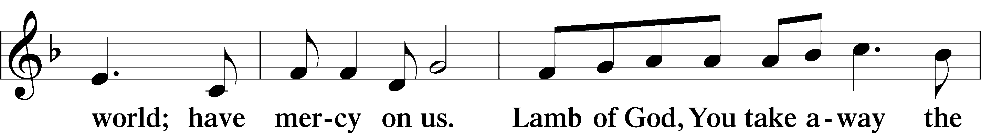
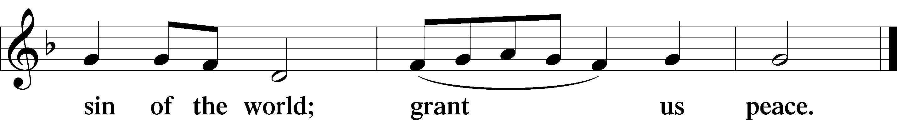

The Distribution

Distribution Hymns
Draw Near and Take the Body of the Lord LSB 637
Children of the Heavenly Father LSB 725
The Gifts Christ Freely Gives LSB 602
Now All The Vault of Heaven Resounds LSB 465

Post-Communion Canticle ~ Thank the Lord
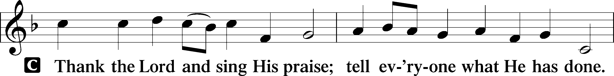
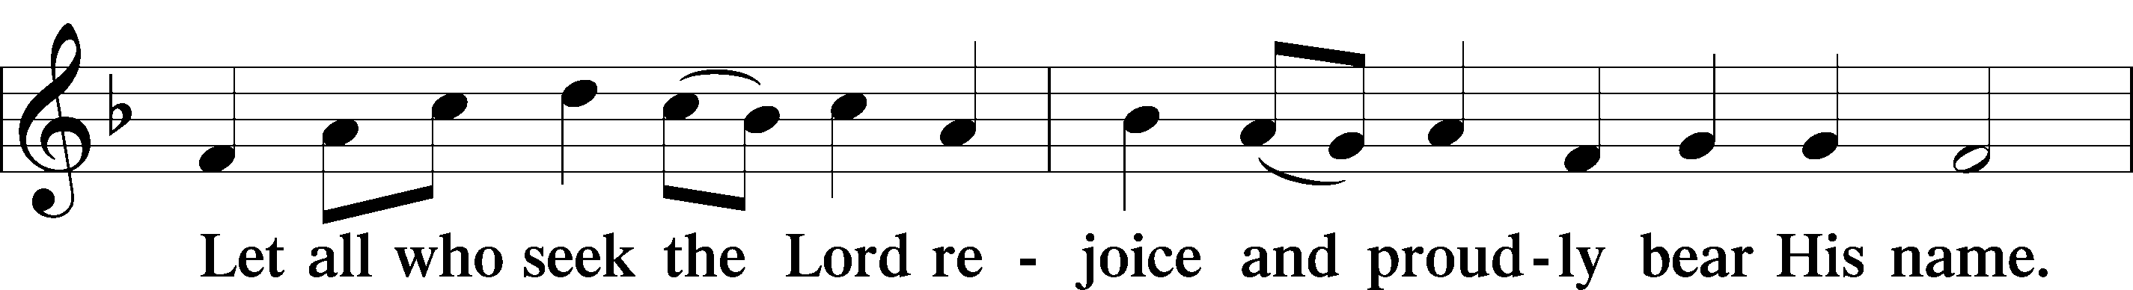
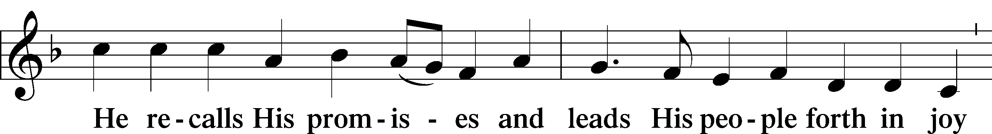
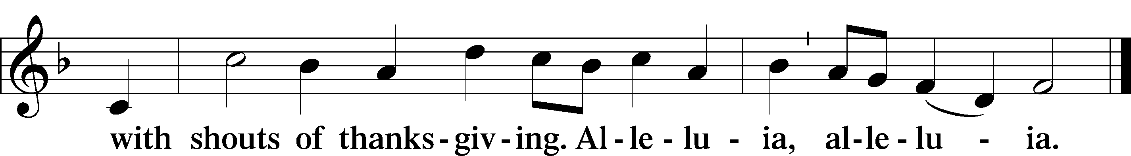

Post-Communion Collect
P: Gracious God, our heavenly Father, You have given us a foretaste of the feast to come in the Holy Supper of Your Son’s body and blood. Keep us firm in the true faith throughout our days of pilgrimage that, on the day of His coming, we may, together with all Your saints, celebrate the marriage feast of the Lamb in His kingdom which has no end; through Jesus Christ, Your Son, our Lord, who lives and reigns with You and the Holy Spirit, one God, now and forever.
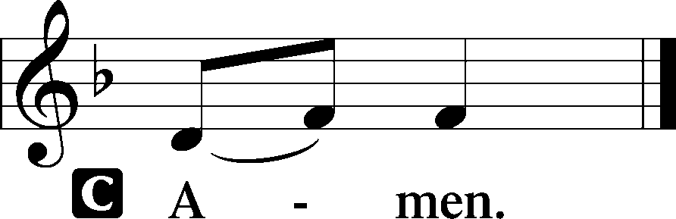
C:

Benediction
P: The Lord bless you and keep you.
The Lord make His face shine upon you and be gracious to you.
The Lord look upon you with favor and give you peace.

C:

Announcements

Departing Hymn
Alleluia! Jesus is Risen LSB 474

P: Go in peace as you serve the Lord.
C: Thanks be to God!

Announcements

\

Church Member Updates - Help us keep our records up to date and keep you informed with what’s happening at Our Redeemer. Please contact the office if your email, phone number or address has changed. You can also download the “Church Center” app on your phone to update your own info, learn some new faces, find contact information, and more.


Prayer Chain - Do you have a prayer request? Share it with the ORLC Prayer Chain, and we will lift your needs in prayer. Submit online at www.orlc-ak.org/prayers, via the Church Center app, or by scanning the QR code. Want to join the Prayer Chain ministry? Just send us a request and we'll add your email to the list.

Alaska Mission for Christ - Thank you for your prayers and support that help share the love of Jesus across Alaska! This month, please join us in giving thanks to the Lord for His steadfast love, grace, and mercy- along with our opportunity to share it! As Psalm 107:1 reminds us, “Give thanks to the Lord, for He is good; His steadfast love endures forever.” Amen! www.amc-ak.org
Pastoral Call Committee Update-
Dear Brothers and Sisters in Christ,

The Call Committee is making steady progress in our search for a pastor to lead our congregation. We have submitted the necessary documents to the District, and they have been received. Currently, we are awaiting the District President's list of vetted and available candidates. Although we wish the list could be provided immediately, we understand that this process requires time.

In the meantime, the committee is diligently preparing interview questions to ensure we find the best fit for our church family once the list is received. We kindly ask for your continued prayers and patience as we navigate through this process. Should you have any questions or concerns, please feel free to reach out to any of the committee members.

Blessings,
Jerry Simpson and the Call Committee

Our Redeemer Activities 11/02-11/09

Today, November 2
Bible Study Hour/Sunday School 9:00 am
Worship Service 10:00 am
Confirmation Class 11:30 am
Deeply Rooted Small Group 5:45 pm

Monday, November 3
Mom’s Group 10:30 am
Seek and Find Small Group 6:30 pm

Tuesday, November 4
Chayon Ryu Martial Arts Class 9:00 am
Elder Momentum Martial Arts Class 10:00 am
Adult Fellowship Potluck 11:30 am

Wednesday, November 5

Thursday, November 6
Chayon Ryu Martial Arts Class 9:00 am
Elder Momentum Martial Arts Class 10:00 am
Elders Meeting 7:00 pm

Friday, November 7

Saturday, November 8

Sunday, November 9
Bible Study Hour/ Sunday School 9:00 am
Worship Service 10:00 am
Ladies Brunch-Bobby’s Café 11:30 am

SERVING OUR LORD AND EACH OTHER
 | THIS WEEK (11/2/2025) | NEXT WEEK (11/9/2025)
Altar Guild | Theo Lee  Evelyn Sampson | Lydia Wirkus  Ingrid Roelfs
Accompanist | Carol Shearer | Carol Shearer
Lector | Carol Shearer | Angie Nishimura
Acolyte | Ember | Broderick
PreK | Ashley  Venita | Leah  Christy
Elementary | Steph | Nicole
Middle School | Heidi (combined with HS) | Tabbie (combined with HS)
High School | Heidi (combined with MS) | Tabbie (combined with MS)




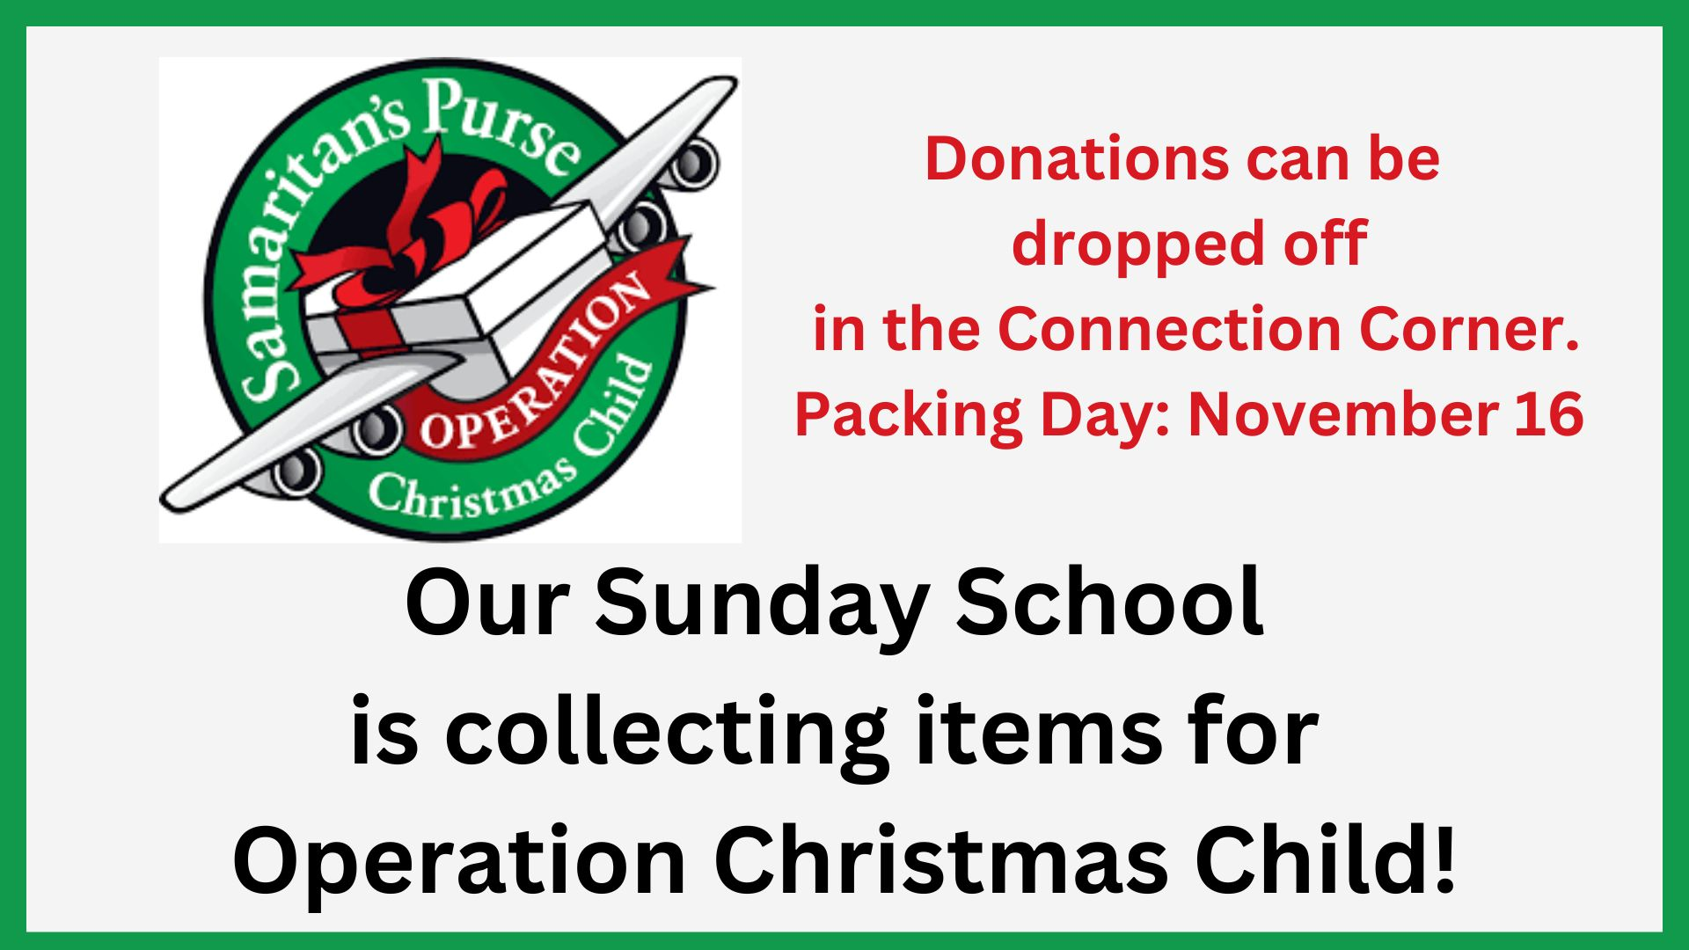


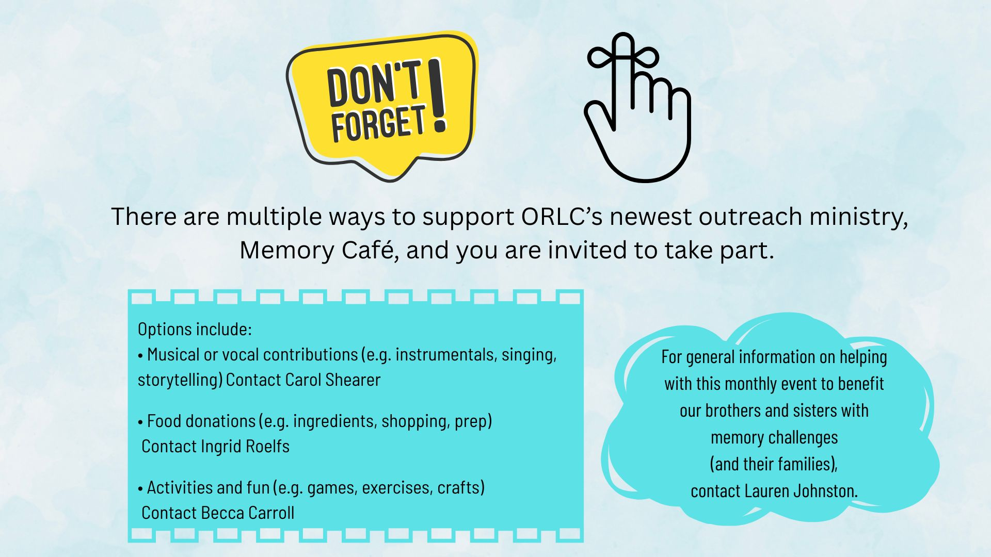

OUR REDEEMER LUTHERAN CHURCH

18444 Old Glenn Highway – P.O. Box 670150 -- Chugiak, Alaska 99567

907-688-2157 | www.orlc-ak.org

All songs are reprinted under Our Redeemer Lutheran Church’s CCLI Number: 246124.

